**New website**

Mirror (https://www.100percent.site)

**theavyproject.io**

**Home – About Avy – Team - Projects – Roadmap – Whitepaper - Tokenomics**

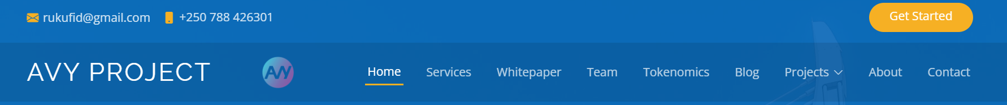

**Home**

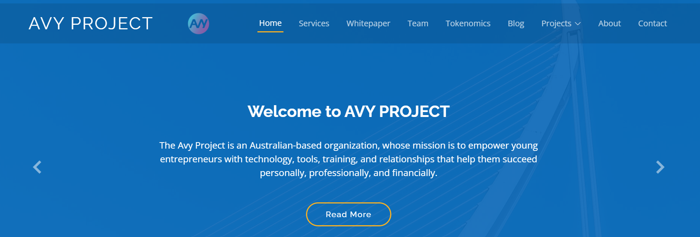

**Welcome to The Avy Project** - The Avy Project is an Australian-based organization, whose mission is to empower young entrepreneurs with technology, tools, training, and relationships that help them succeed personally, professionally, and financially.

**Team** – Our team was built on community through the Founder Ronnie El Cheikh in Australia and is now spread globally. With a diverse set of skills contributing to a world community project.

**Projects** - Avy is involved in 5 Projects, our world leading Blockchain and Academy, our Avy marketplace, Our NFT collections, our Avy network infrastructure and Mining Devices and our Avy Humanity Token. Built off our amazing and growing community.

**Roadmap** – Our roadmap focuses on community and social impact, improving the livelihoods of our people is our primary focus. Each project ours is broken into key verticals, our road to global change is identified in our roadmap pillars starting with investment.

**Whitepaper** – In our attached Whitepaper we clearly define our business plan and model for success. The Avy project has a clear Mission and Vision to change the lives of our communities through action and change.

**Tokenomics** – Our Avy Token is an equalizer and game changer, it has utility beyond the market as it focuses on building value and equity through our very community that builds a unique ecosystem.

**About Avy**

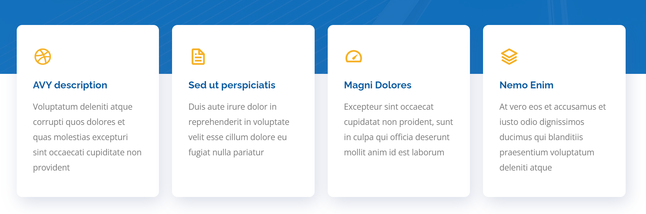

Our worlds are changing rapidly, we must adjust to the new digital world. Welcome to The Avy Project, where community meets blockchain and we change people’s lives through our Academy, NFT projects, unique mining devices, our Internet and Avy network services and our Token that links it altogether.

Imagine a world with equalization, a fairness system that enables marginalized communities’ access to the training and education and then having the opportunity to utilize their skills for sustained independence. A learn to earn system.

Our blockchain will enable a token that will be linked to nominated social impact programs that enable lifelong change. Using Cryptocurrency ensures our community has a share in the latest opportunities to be progressive in their ability to create independence.

Do you see an equalized world?

We have longed for the change to create a solid business to change people’s lives.

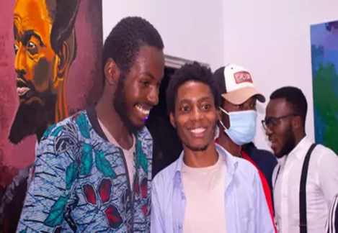 

**Team**

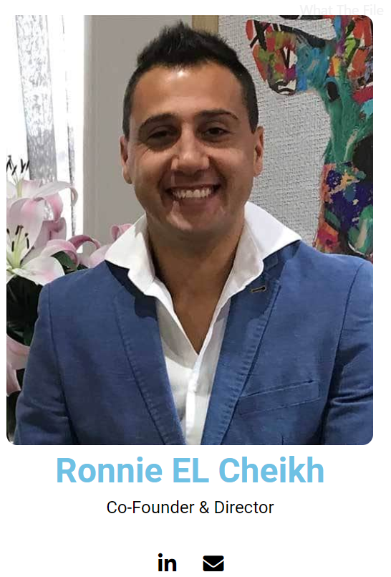

A serial entrepreneur and business operations leader. Founder & Director of multiple businesses in Australia, bringing a wealth of business prowess. A Co-Founder of a Non-Governmental Organization in Australia, which plays major parts in Social Impact programs. The Avy Project is the latest business project within the portfolio, the business model and sustainable project will be pivotal to world change. With the operations experience and extensive business leadership The Avy project will prosper.

**Projects**

**Avy Academy Avy Marketplace The Avy NFT Collection Avy Network & Avy Token**

**Mining Devices**

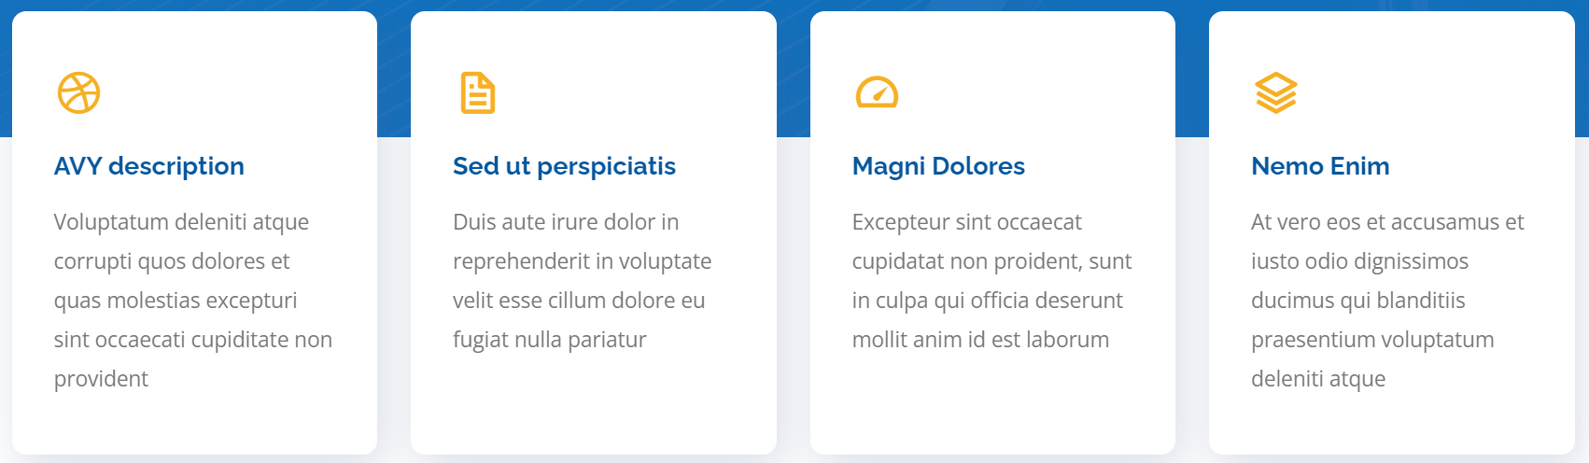

**Avy Academy**

<https://avyacademy.com/>

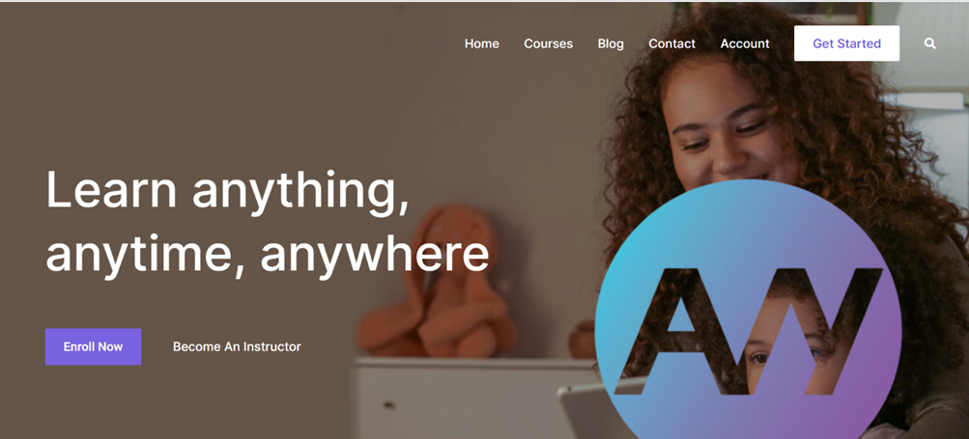

**Avy Marketplace**

<https://avyapps.com/>

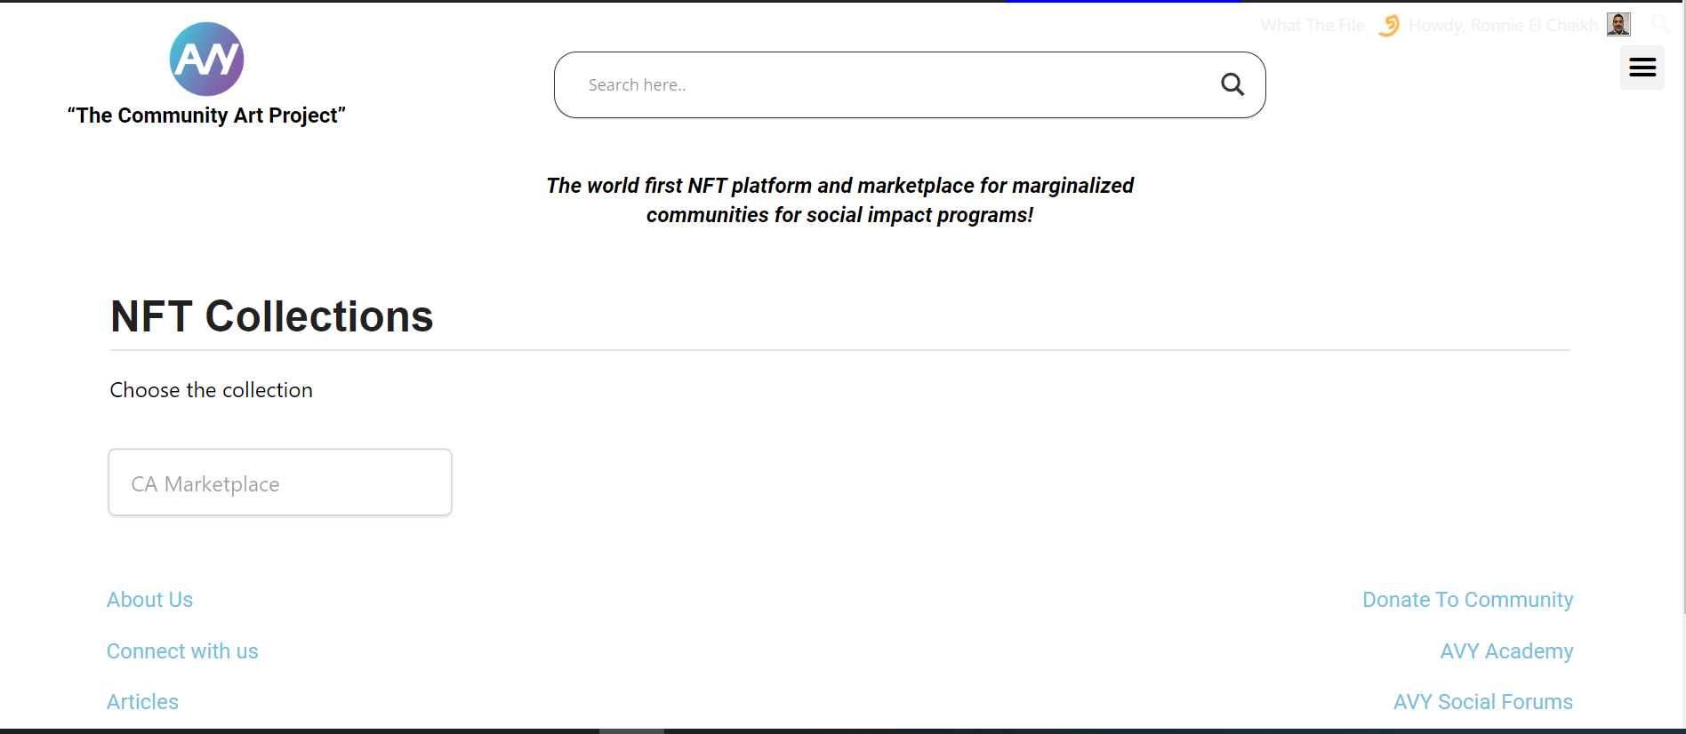

**The Avy NFT Collection**

We will have a collection of NFTs (Theme yet to be chosen) for each country we collaborate with. These NFT’s will be linked back to nominated projects and 50% of the sales will go back to NGOs for (Food, Water, Shelter, Education, Infrastructure, Human Rights, Internet and many other projects)

More to come…………….

**The Avy Network & Devices**

The Avy Project has patented technology for our laptop mining devices, that connect to our IaaS Avy Network whilst earning Cryptocurrency and Avy Tokens. Our devices allow you to use it as an everyday device Personal Computer whilst mining currency, use our devices on our Avy Academy education platform or Avy Marketplace.

Patented Technology and unique powering of our devices ensuring our global footprint on Environmental, Social and Corporate Governance ESG. Below are some unique features.

**TV WHITE SPACE TV - WI-FI – Bluetooth** - **Near Field Communication**



**The Avy Token**

**Market supply 1 billion Tokens**

**(Owners Token)** Founders and Investors will receive tokens being part of The Avy project

Allocation **(500,000,000 tokens) 50% liquidity**

**(Academy Token)** for each level completed by the artists, there are 5 levels so they will receive 1000 x Tokens

Allocation 10,000 students **(1,000,000 tokens) 0.001% liquidity**

**(Device Owner Token)** Any device purchased by the community would receive 500 tokens per purchase of the laptop

Allocation 100,000 devices **(50,000,000 tokens) 5% liquidity**

**(Mining Tokens)** Once subscribed to the Avy network monthly users would mine Avy tokens

Allocation **(40,000,000 tokens) 4% liquidity**

**(Public Token)** There will be an ITO and ICO for the Avy token, it will be through a market cap

Allocation **(400,000,000 tokens) 40% liquidity**

(**Marketplace Users Token)** will be given to Sellers and collectors of NFT artworks on the marketplace

Allocation **(1,000,000 tokens) 0.001% liquidity**

**(Donate Token)** The Avy Project will donate tokens to NGOs in partnership

Each NGO gets 1000 Tokens Allocation **(8,000,000 tokens) 0.008% liquidity**

**Use the bottom design and breakdown % in graph**

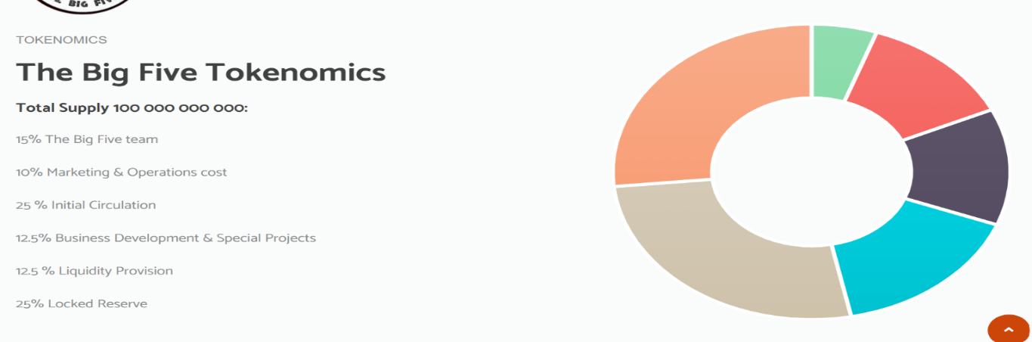

**Roadmap**

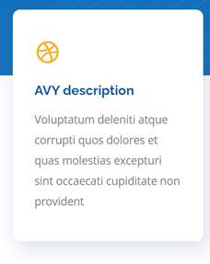

Design Roadmap like below:

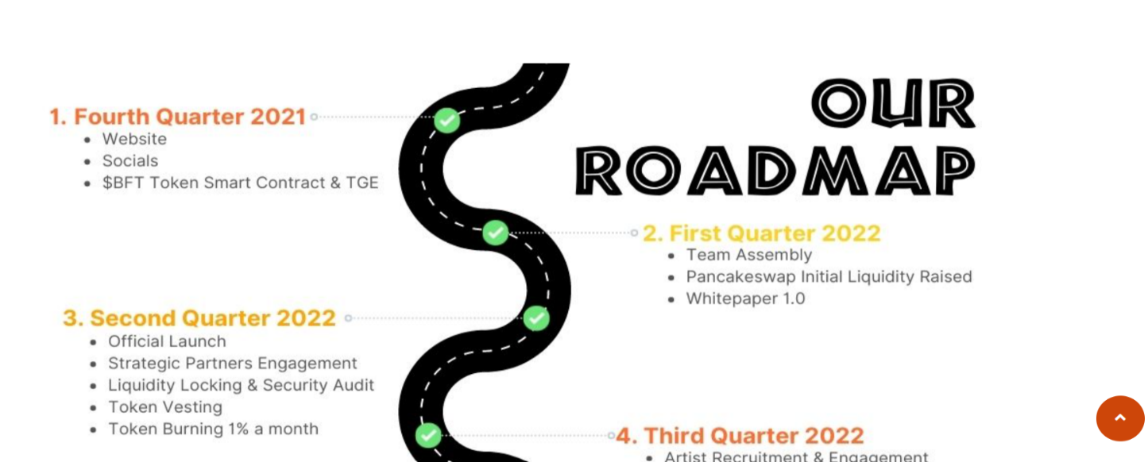

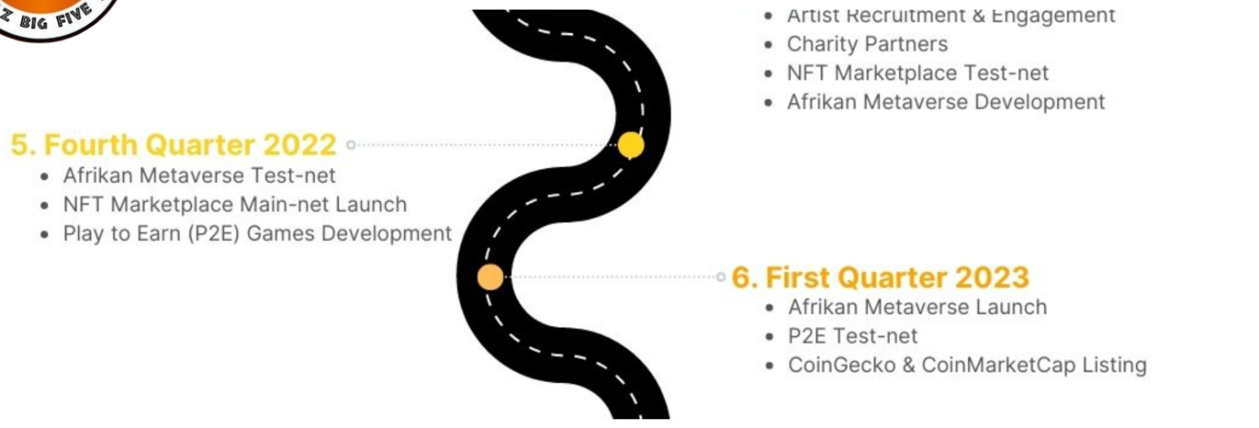

**Whitepaper**

We believe that decentralization is the key to empowering people all over the world. The Avy Project has 5 core business streams.

The Academy will educate and nurture our community in the 21st century of Blockchain and decentralization. We have a responsibility to communities to equalize and improve basic access to the digital world. The Avy platform engages NGOs and their artists to use the Avy Apps marketplace to sell their real NFTs after completion of the Avy Academy. They will be rewarded with our Tokens.

The NFT Collection creates the opportunity for the community to benefit from these sales providing the revenue into social impact. The Internet as a Service and having our very own mining devices that connect to the Avy Network, will be key to improve Education and access to the Digital world through our utility and rewarded with our Tokens.

The Avy Token will play a pivotal role in our blockchain to ensure we change the lives of our community through the digital world. The token is linked through social impact, and we cover its function in the Whitepaper

**Register here for the whitepaper and whitelist and receive 50 Avy Tokens**

**Name**

**Contact email**

**Telegram or Discord**